**What is agile? List some of Agile Frameworks?**

Scrum (70%)

Kanban (5%)

ScrumBan (8%)

Extreme Programming (1%)

**How is agile methodology different from the traditional waterfall process?**

**Describe scrum? Scrum Framework**

**Scrum Roles:**

**Scrum Artifacts:**

**Scrum Ceremonies:**

**What is spike?**

Spike is the type of story where team need to do some research related to the design or

technical issues. Spikes will have 0 story points.

**What is an epic?**

**Explain what Velocity is in Agile?**

Velocity is the sum of story points that a scrum team completes (meets the definition of

done) over a sprint. It figures out how much work a team can complete in a sprint and

how much time will it need to finish a project.

**How do you track your progress in a sprint?**

The progress is tracked by a “Burn-Down chart”. A burndown chart is a graphical

representation of work left to do versus time.

**What is DoD? How is this achieved?**

DoD stands for Definition of done. It is achieved when

The story is development complete,

QA complete,

Regression around the story is complete

The feature is eligible to be shipped / deployed in production.

**Is it possible that you come across different story points for development and**

**testing efforts? In that case how do you resolve this conflict?**

Yes, this is a very common scenario. There may be a chance that the story point given by

the development team is, say 3 but the tester gives it 5. In that case both the developer

and tester have to justify their story point, have discussion in the meeting and collaborate

to conclude a common story point.

**You are in the middle of a sprint and suddenly the product owner comes with a new**

**requirement, what will you do? Send to working story in backlog**

**SDLC QUESTIONS**

**What is SDLC?**

**What is water fall?**

**What is BA rule?**

**When use water fall?**

**What are disadvantages of water fall?**

**What is agile**

**What are disadvantages of agile ??**

**What are the types of agile frameworks.?**

**What is agile scrum ?**

**What is product owner ??**

**What is scrum master??**

**What is development team?**

**What is artifact ?? artifact is physical sketch, a document of sketch of user story layout of the process which we have to build the software**

**What is product backlog?? Combination of user stories**

**What is sprint backlog ???**

**-- sprint is iteration , sprint is not a document, a sprint is a time-boxed iteration during which a specific amount of work is completed. Sprints are typically short, ranging from one to four weeks in duration.**

**What is burn down chart?**

**What is ceremonies ?/ meetings**

**1. daily stand up ??**

**Sprint grooming – user story not clear understand**

**Sprint planning ---how much time will take to complete, dev and tester**

**Sprint review -- owner include , to show the software to the owner ,take feedback, use feedback for next sprint**

**Sprint retrospective –saabqa , pahly wala --- end of sprit, what were the issue , problems, openly can talk.**

**--------------------------------------------------------------------------------------------------------------------------------------------------------------------------------------------------------------------------------------------------------------------------------------------------------------------------------------------------------------------------------------------------------------------------------------------------------------------------------------------------------------------------------------------------------------------------------------------------------------------------------------------------**

**Class -01 manual testing;**

**What is manual testing?**

**What is the goal of testing?? To make defect free**

**Types of application??**

**What are web application?**

**Desktop application?**

**Mobile application???**

**What is STLC??**

**Why we test ?? working as expected**

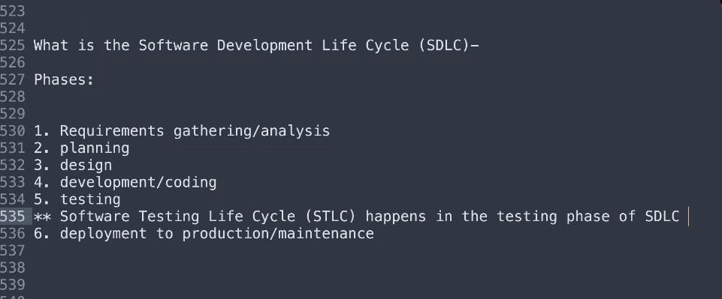

**What is business requirement? User stories.**

**What is acceptance criteria? Is just the summary of requirements.**

**What is user story?? - user story is the requirement or functionality.**

**is the summarize (details, khalasa ) requirement, basically describe what the user should do ??? example. I should be able to go amazon and navigate to prime video.**

**STLC**

**1. requirement analysis ------- read requirement according smart criteria**

**Write first manual test case;**

**What is step – step is the action .**

**What is pre-condition**

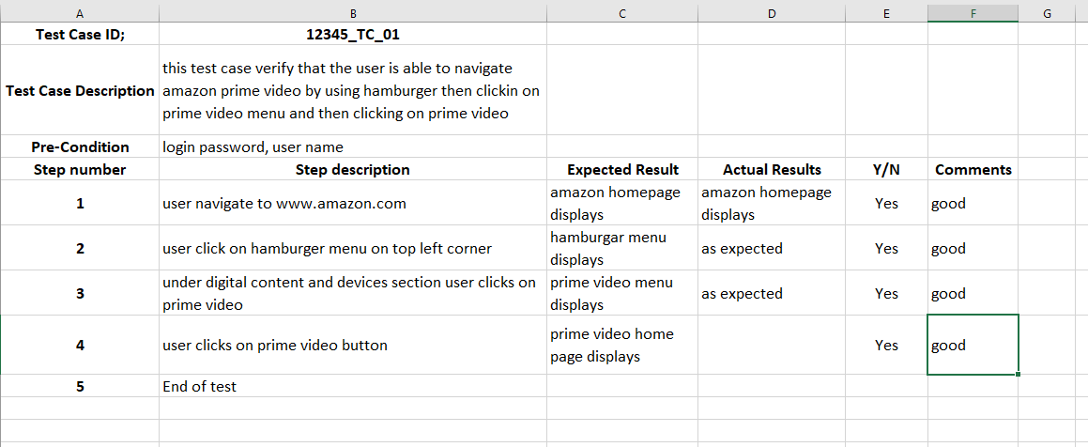

**---------------------------------------------------------------------------------------------------------------------------------------------------------------------------------------------------------------------------------------------------------------------------------------------------------------------------------------------------------------------------------------**

**CLASS 02 , MANUAL TESTING;**

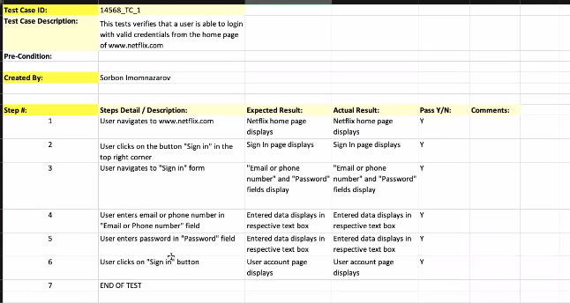

**What is levels of testing/testing environment?**

**What is development environment? -- developers**

**What it testing environment? QA team testing**

**What is staging environment? --- owner do testing here**

**What is production environment? --- live customer, end user**

**--------------------------------------------------------------------------------------------------------------------------------------------------------------------------------------------------------------------------------------------------------------------------------------------------------------------------------------**

**Manual testing class 03**

**What is bug ??? any fault, defect , problem , issue in software.**

**Why bug occur??? Human mistake, gathering requirement 56%**

**When bug occur then what to do?? Reproduce it 5 times,**

**What is intermittent bug? That occur and not occur, some time occur some time not.**

**How Reporting Works? What should be included in Reporting? --- Time**

**What is bug life cycle?? It starts when you want to report a bug—read user story before reporting a bug. Make a document which bug is occurred**

**What is functional testing?? Is performed by manual tester and auto tester. Check box, button, links,**

**Black box testing.**

The testing in which internal part of coding is not tested,

**What is non functional testing/white box testing/unit testing/development testing??**

**White box/unit/development -- performed by the developer**

**Performance testing, security testing, load testing**

**What is difference in testing hierarchy and testing environment?**

**Hirerachy mean testing at different level, environment mean testing at different stages.**

**There are 4 testing environment**

**1. development**

**2.testing**

**3.staging**

**4.production**

**What is smoke testing? -- testing of main functions/functional testing**

**What is regression testing??—functional testing/** regression testing mean after any update or fixing bug or any change in application is then still the application’s other functions are working which were already correct.

508 compliance testing? For disable people , job access with speech

Ad hoc testing/ random testing done by every person.

**---------------------------------------------------------------------------------------------------------------------------------------------------------------------------------------------------------------------------------------------------------------------------------------------------------------------------------------------------------------------------------------------------------------------------------------------------------------------------------------------------------------------------------------------------------------------------------------------------------------------------------------------------------------------------------**

**Class 04 manual Testing.**

**What is jira??**

**Jira is project management tool.**

**What is issue/ticket????**

**everything in jira is an issue, task is issue, test case is issue, user story is issue everything in Jira is called issue but in other project management tool they call tickets**

**JIRA is used to manage for just manual testing.**

**-------------------------------------------------------------------------------------------------------**

**Where you organize your test case?? In jira.**

**What is beta testing? To get feed back from the user.**

**What is 508 compliance testing?? Disable person can use the app – in mobile accessibility feature/narrator in window.**

**What is Boundary Testing?**

**What is Negative Testing and what is Positive Testing? Valid and invalid credentials**

**What is non-functional testing? Have you done any performance testing?**

**What is Functional testing?**

**What is ?**

Unit testing

● Integration testing

● Regression testing

● Ad-Hoc

● Smoke testing

● Performance testing

● System testing

● UAT Testing

**7. In which phase should testing begin?**

**What is the difference between regression testing and retesting? Retesting after the bug fix.**

**When is a test considered to be successful? When it discovers more errors in your software product are considered more successful.**

**If there isn’t enough time for testing, what would you do? I will talk to team, priority task.**

**What would you do if you end up with unclear requirements or requirements are**

**not available? Talk with your BA**

**What is the difference between bug release and bug leakage?**

**How do you deal with a bug which is not consistently reproducible/intermittent?**

**How do you define the bug life cycle?**

**What is test coverage?**

What are we testing and How much are we testing!

**Who is responsible for writing test cases and test plans?**

**What is a test case and what does it include?**

**What is Test Strategy?**

A Test Strategy document is a high level document and normally developed by the

project manager. This document defines “Software Testing Approach” to achieve testing

objectives. It sets the standards for testing processes and activities.

**What is a Test Plan?**

The Test Plan document is usually prepared by the Test Lead or QA Manager and the

focus of the document is to describe what to test, how to test, when to test and who will

do what test.

**Tell us some key challenges you face in the Testing industry?**

1. Requirements changing.
2. Application not stable. – crashing software while testing
3. Unclear requirements -- ambiguity
4. **Resource limitations:** Testing teams may not have access to sufficient resources, such as skilled testers, testing tools, or testing environments, which can hinder the quality and coverage of testing.
5. **Communication gaps:** Poor communication between stakeholders, such as developers, testers, and business analysts, can lead to misunderstandings, delays in bug fixes, and inefficiencies in the testing process.

**A Requirements Traceability Matrix (RTM)** is a simple tool used in software testing and project management to ensure that all requirements are covered by test cases.

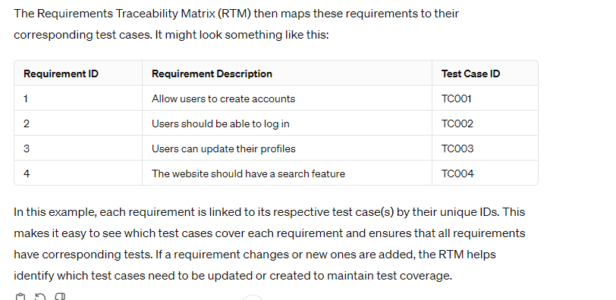

**When is a test considered to be successful?**

Tests that cover more functionalities and discover more errors in your software product

are considered more successful.

**What is the difference between system testing and integration testing?**

**What is the difference between regression testing and retesting?**

**What is non-functional testing? Have you done any performance testing?**

**What is Negative Testing and what is Positive Testing?**

**What is Boundary Testing? Valid data in valid boundary**

**What is 508 Compliance testing?**

**What is Beta Testing?** Beta testing is conducted to gather feedback from the real-time usage of gaming industry they release a game to a certain audience before a mass

release to get feedback.

**What is the difference between UAT and QA? What is Acceptance testing?**

**What is Integration testing?**

**What is unit testing, and have you ever done unit testing?**

**What is Ad-Hoc Testing? Exploratory testing? Random Testing?**

**In which phase should testing begin?**

**Can you tell different types of testing you are aware of?**

**What Is the Difference between Black Box and White Box testing?**

**What is the difference between static and dynamic testing?** White Box testing technique where the developers verify or test their code with the help of a checklist to find errors in it, this type of testing is done without running the developed application or program

Dynamic Testing is done by executing the actual application with valid inputs to check

the expected output.

**Can you tell the Difference between Verification and Validation?**

**Why do Software Applications have bugs?**

**Can you tell the difference between STLC (Software Testing Life Cycle) and SDLC**

**(Software Development Life Cycle)?**